Sierra Leone

## GNI per capita and development level

The data set shows the GNI per capita and development level of the country each year.

## # A tibble: 19 x 5  
## country iso3c date GNIperCapita devCategory   
## <chr> <chr> <dbl> <dbl> <chr>   
## 1 Sierra Leone SLE 1996 2076. Lower Middle Income  
## 2 Sierra Leone SLE 1998 2648. Lower Middle Income  
## 3 Sierra Leone SLE 2000 554. Low Income   
## 4 Sierra Leone SLE 2002 323. Low Income   
## 5 Sierra Leone SLE 2003 338. Low Income   
## 6 Sierra Leone SLE 2004 344. Low Income   
## 7 Sierra Leone SLE 2005 346. Low Income   
## 8 Sierra Leone SLE 2006 350. Low Income   
## 9 Sierra Leone SLE 2007 394. Low Income   
## 10 Sierra Leone SLE 2008 416. Low Income   
## 11 Sierra Leone SLE 2009 424. Low Income   
## 12 Sierra Leone SLE 2010 406. Low Income   
## 13 Sierra Leone SLE 2011 412. Low Income   
## 14 Sierra Leone SLE 2012 486. Low Income   
## 15 Sierra Leone SLE 2013 552. Low Income   
## 16 Sierra Leone SLE 2014 556. Low Income   
## 17 Sierra Leone SLE 2015 435. Low Income   
## 18 Sierra Leone SLE 2016 408. Low Income   
## 19 Sierra Leone SLE 2017 452. Low Income

## GDP growth and economic growth classification

The data set shows the GDP growth and the ecomic growth classification of the country each year.

## # A tibble: 19 x 5  
## country iso3c date GDPannualGrowthRate GDPgrowthCategory4  
## <chr> <chr> <dbl> <dbl> <fct>   
## 1 Sierra Leone SLE 1996 1.75 slow growth   
## 2 Sierra Leone SLE 1998 1.79 slow growth   
## 3 Sierra Leone SLE 2000 6.65 fast growth   
## 4 Sierra Leone SLE 2002 26.4 fast growth   
## 5 Sierra Leone SLE 2003 9.31 fast growth   
## 6 Sierra Leone SLE 2004 6.60 fast growth   
## 7 Sierra Leone SLE 2005 4.51 moderate growth   
## 8 Sierra Leone SLE 2006 4.22 moderate growth   
## 9 Sierra Leone SLE 2007 8.06 fast growth   
## 10 Sierra Leone SLE 2008 5.40 moderate growth   
## 11 Sierra Leone SLE 2009 3.19 moderate growth   
## 12 Sierra Leone SLE 2010 5.35 moderate growth   
## 13 Sierra Leone SLE 2011 6.32 fast growth   
## 14 Sierra Leone SLE 2012 15.2 fast growth   
## 15 Sierra Leone SLE 2013 20.7 fast growth   
## 16 Sierra Leone SLE 2014 4.56 moderate growth   
## 17 Sierra Leone SLE 2015 -20.6 negative grwoth   
## 18 Sierra Leone SLE 2016 6.06 fast growth   
## 19 Sierra Leone SLE 2017 4.21 moderate growth

## Development trend

The plot shows the development trend of the country.

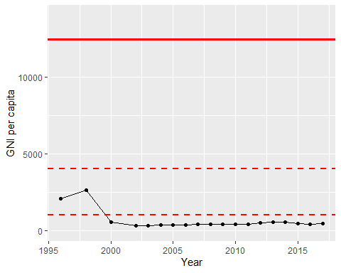

GNI Per Capita Trend